**Students Achievements**

* **TCS Code Vita Winners- Two Teams were selected from CSE GGITS out of 12 Teams from entire Western Region.**

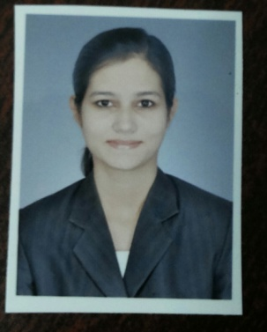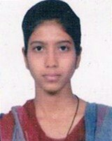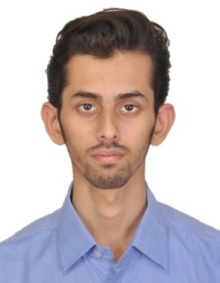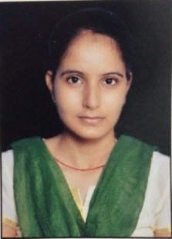

**Team 1 -Rashika Sharma and Rewati Yadav-**

**Ranked 91 in Round 1 of TCS Codevita 2015 in India (6 Teams - 12 Students were selected from Mumbai Region).**

**Team 2-Priyanshu Gupta and Pallavi Muley-**

**Ranked 899 in Round 1 of TCS Codevita 2015 in India. (6 Teams - 12 Students were selected from Mumbai Region). Amongst Top 300 teams in TCS Testimony 2015 in India.**

* **Microsoft Imagine Cup National Finalist**

**A team of 3 candidates were National Finalist in Microsoft imagine cup 2015 under innovation category in Global Student Technology Competition by Microsoft, representing Gyan Ganga Institute of Technology and Sciences.**

* **Abhishek Hingnikar CSE 8th sem**
* **Purvi Jain IT 6th sem**
* **Deepali Kushwaha CSE 6th sem**

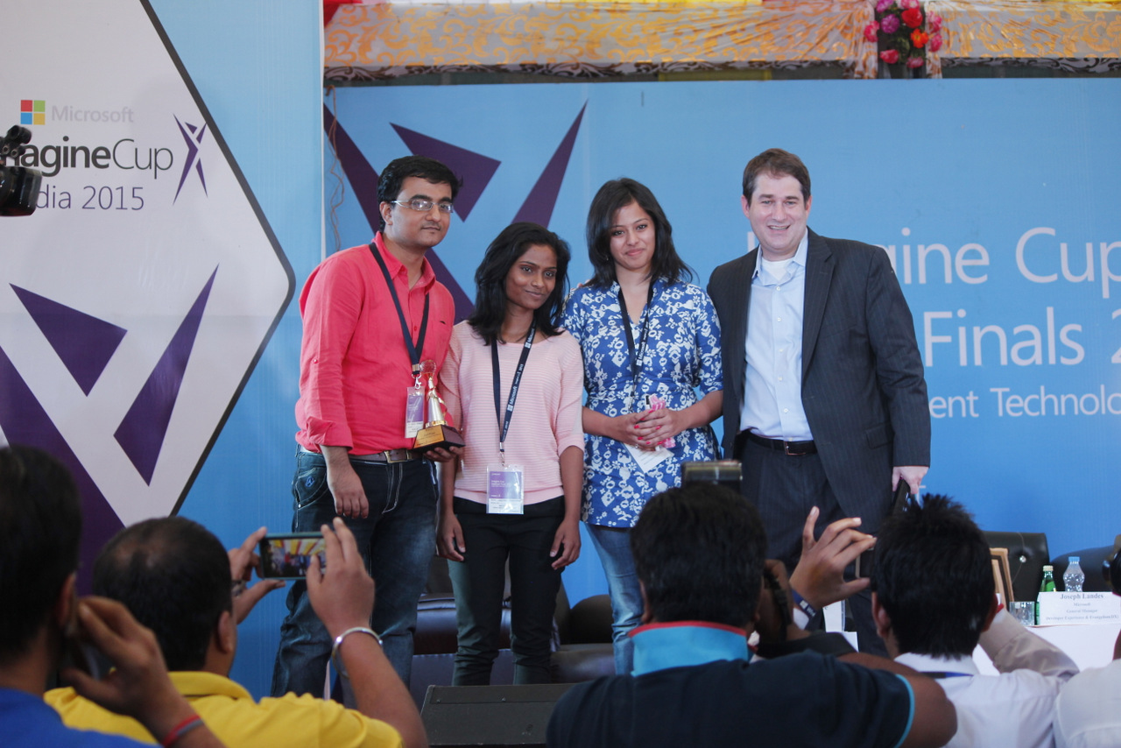

* **Persistent COE Selections**

Following students were selected in Live Project of Persistent Systems after Online Test conducted under Centre of Excellence.

